Press Release

Method Park is a Scaled Agile Bronze Transformation Partner now
Importance of SAFe® strengthened in the Method Park portfolio
Method Park joined the Scaled Agile Partner Program as a response to the increased demand for consulting on Agile Transformation and Organizational Development.
Erlangen, July 14, 2020 - Method Park joined the Scaled Agile Partner Network. As a Bronze Partner, Method Park offers training and courses on all SAFe® roles, prepares for certifications, advises and accompanies organizations across all industries and disciplines in the implementation of the framework.
Important Consulting Topics
Dr. Tobias Maier, Principal Consultant at Method Park and responsible for the topic of Organizational Change, explains: "SAFe® plays an increasingly important role in our service portfolio for Agile Transformation and Organizational Development. The membership in the partner network emphasizes our SAFe® competence".
Expertise and Experience
As a Scaled Agile Partner, Method Park offers the expertise and experience in supporting large corporations and government agencies to succeed in their Lean-Agile Transformation with SAFe®. Method Park imparts the principles of SAFe® and addresses all key stakeholders in a SAFe® implementation.
Know-how Sourcing Pool
In their organizational development, Method Park customers also benefit from a know-how sourcing pool that is well connected with the SAFe® partner network. Method Park now has access to exclusive training material, toolkits, and downloads for consulting and training.
Number of characters (space characters included): 1.542
About Method Park
Method Park specializes in complex product engineering in the environments of the automotive, medical, and aerospace industries. Method Park's portfolio includes consulting and engineering services, a comprehensive training program, and the process management tool "Stages".
Method Park was founded in 2001. On a worldwide basis, the company has supported and coached its customers on process optimization, compliance to industry-specific standards, and legal regulations, as well as the management of projects, products, and quality assurance. Method Park offers a practice-based training program on all current topics of Software & Systems Engineering in Europe, the US, and Asia.
With "Stages", Method Park offers a model-based process management tool, which supports its users on the definition, communication, and application of complex processes.
With around 200 employees, the company group has locations in Erlangen, Frankfurt on the Main, Hamburg, Munich and Stuttgart as well as in Detroit, Miami and Pittsburgh in the US and Shanghai in China. In 2019, Method Park generated an operative turnover of about 21 million euros.

For further information, please contact:
Dr. Christina Ohde-Benna, PR-Assistant
Method Park Holding AG, Wetterkreuz 19a, 91058 Erlangen, Germany
Christina.Ohde-Benna@methodpark.de www.methodpark.com

Available pictures:

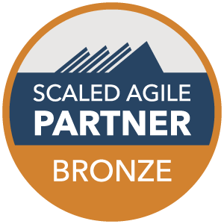
Caption: Method Park is a Scaled Agile Bronze Transformation Partner
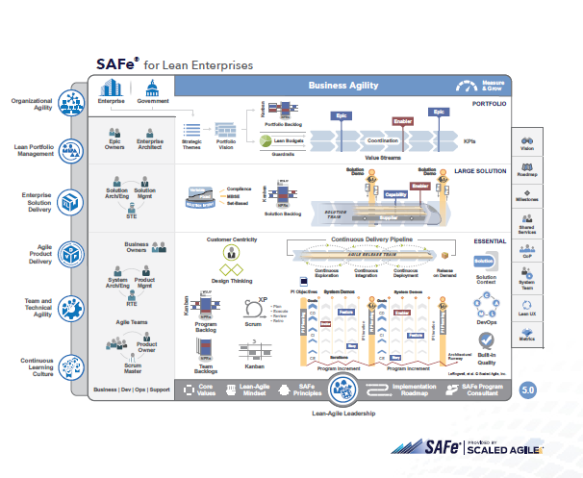
Caption: Full SAFe supports building large, integrated solutions that typically require hundreds of people or more to develop and maintain. (© Scaled Agile, Inc.)

