Press Release Event Review

Process Insights Germany 2020 in Fuerth
Over 70 participants discuss current challenges in process management
The impact of agile on development processes was one of the central topics at the Process Insights Germany 2020 conference. Since 2006, Method Park has invited once a year to participate in the event.
Erlangen, March 19, 2020 – Over 70 participants followed Method Park's invitation and attended the conference in Fuerth on March 11 & 12 to find out about the challenges and solutions in modern process management and to learn from best practices at Process Insights Germany 2020.

Focus on Agile
The agile transformation and its impact on product development processes, functional safety, and process-based variant management were the key topics of presentations, round tables, and the Consulting Café. The discussions during the conference, in the accompanying exhibition, and at the evening event primarily focused on the innovations offered by the latest version of the process management tool Stages.
Anitra Eggler’s keynote speech, "Keep your mail shut!" was a particular highlight. She moved the participants' attention to digital overload and triggered a lively discussion about permanent accessibility.
Two preceding workshops offered hands-on support for the modeling and optimization of development processes.

Attendees of Various Industries
Representatives of companies from many different industries, such as the automotive industry, medical technology, rail, aerospace, IT consulting, and universities, participated in Process Insights. The feedback from the participants was entirely positive. "The program committee with representatives from Audi, Bosch, Hella, and Schaeffler put together a richly diverse agenda. The exciting presentations and practice-oriented workshops offered exciting insights, tips & tricks for process management," summarized Prof. Dr. Bernd Hindel, Method Park CEO.

Positive Appraisal
The location also received throughout positive feedback. The Ronhof sports park, with its spacious premises, was the perfect location for Process Insights Germany. "Interesting presentations, a great location, excellent catering - an entirely successful event" is the conclusion of many participants. "That is why we will host Process Insights Germany at the Ronhof sports park again next year," says Method Park CTO Dr. Erich Meier. Method Park already set a date: March 10 & 11, 2021.
Number of characters (space characters included): 2.411
About Method Park
Method Park specializes in complex product engineering for the automotive, medical, and aerospace industries. Method Park’s portfolio includes consulting and engineering services, a comprehensive training program, and the process management tool “Stages”.
Method Park was founded in 2001. On a worldwide basis, the company has supported and coached its customers on process optimization, compliance to industry-specific standards and legal regulations, as well as the management of projects, products, and quality assurance. Method Park offers a practice-based training program on all current topics of Software & Systems Engineering. In 2017, Method Park became an official VDA QMC training provider of Automotive SPICE® courses. For the recent version of Automotive SPICE® V3.1, Method Park has developed a free app for iOS and Android.
With “Stages”, Method Park offers a model-based process management tool, which supports its users on the definition, communication, and application of complex processes, particularly in the engineering environment – globally, beyond organizational borders and always in compliance with various industry-specific standards.
With around 200 employees, the company group has locations in Erlangen, Frankfurt on the Main, Hamburg, Munich and Stuttgart as well as in Detroit, Miami and Pittsburgh in the US and Shanghai in China. In 2019, Method Park generated an operative turnover of about 21 million euros.

For further information, please contact:
Dr. Christina Ohde-Benna, PR-Assistant
Method Park Holding AG, Wetterkreuz 19a, 91058 Erlangen, Germany
Christina.Ohde-Benna@methodpark.de www.methodpark.com
Available pictures:
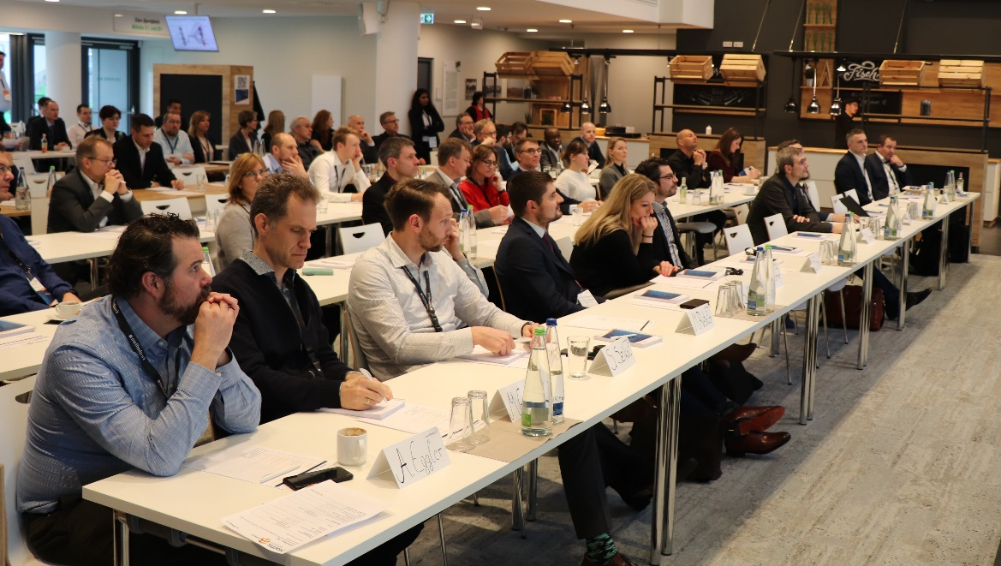
Over 70 participants followed Method Park's invitation to attend Process Insights Germany for two days to find out about the challenges and solutions for their process management.

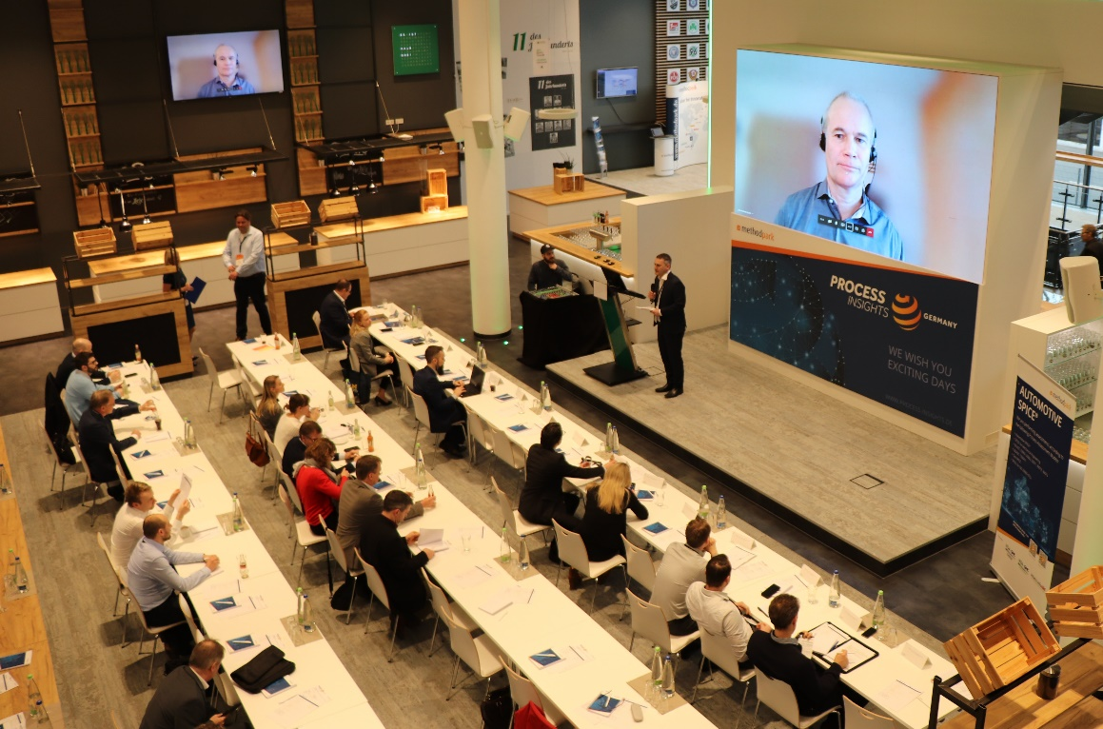
Video streaming at Process Insights Germany: Peter Fassbinder from Siemens was streamed live for his presentation on industrial quality standards.

