Staff notification

Robin Hees appointed to the Management Board of Method Park Holding AG
Expansion of the Method Park Management Board underlines the group of companies’ growth course
Method Park is expanding its Management Board immediately with financial expert Robin Hees. As CFO, Robin Hees will ensure the sustainable future orientation of the Group.
Erlangen, November 12, 2019 – Effective November 1, 2019, Robin Hees will join the Management Board of Method Park Holding AG as CFO. With this appointment, Method Park continues to pursue a clearly future-oriented strategy in order to keep the company on a sustainable growth course.

Long-term professional experience in management positions
Robin Hees was most recently the Managing Director of Barat Ceramics GmbH (later QSIL Ceramics) and before that, Managing Director of Siemens Audiologische Technik GmbH (later Sivantos Group) for many years. He played a decisive role in this unit becoming independent and separating from the Siemens Group.
Robin Hees previously held various management positions in the Siemens Group and the Financial Advisory Division of the WTS Group. He is regarded as an outstanding expert for all commercial tasks in controlling, finance and accounting.

Exciting tasks in a dynamic environment
"I am looking forward to my new task and to cooperating with the executive team around Prof. Bernd Hindel as well as the whole Method Park team!", says Robin Hees. "The challenges ahead and our ambitious growth plans promise to be a truly exciting task in a very dynamic environment!”
Prof. Bernd Hindel, Chairman and CEO, is pleased that Method Park has gained Robin Hees, an experienced manager who will support the company in its future-oriented growth strategy from now on. "We see great potential, above all in international expansion, the further development of our portfolio of pioneering solutions for our customers and the further optimization of administrative processes, combined with a sense of proportion and responsibility, especially for our employees.”
Number of keystrokes (incl. spaces): 2,023
About Method Park
Method Park is a specialist for innovative software & systems engineering in the safety-critical environments of medical and automotive technology. The portfolio includes consulting and engineering services, a comprehensive training program and the process management tool "Stages".
Since its founding in 2001, Method Park has advised, supported and coached clients worldwide in optimizing process flows, complying with industry-specific standards and legal regulations, and managing projects, products and their quality. Method Park offers a practice-oriented seminar program on current topics in Software & Systems Engineering. Seminar locations can be found in Germany, other European countries, the USA and Asia.
With "Stages", Method Park has launched an individually adaptable process management tool on the market that supports the user in defining, communicating and applying complex processes.
The Group has offices in Erlangen, Frankfurt am Main, Hamburg, Munich and Stuttgart in Germany as well as in Detroit, Miami and Pittsburgh in the USA. Method Park currently employs around 200 people and achieved operating sales of around EUR 19 million in 2018.
For further information please contact:
Dr. Christina Ohde-Benna, PR-Assistant
Method Park Holding AG, Wetterkreuz 19a, 91058 Erlangen, Germany
Christina.Ohde-Benna@methodpark.de www.methodpark.com
Available pictures:
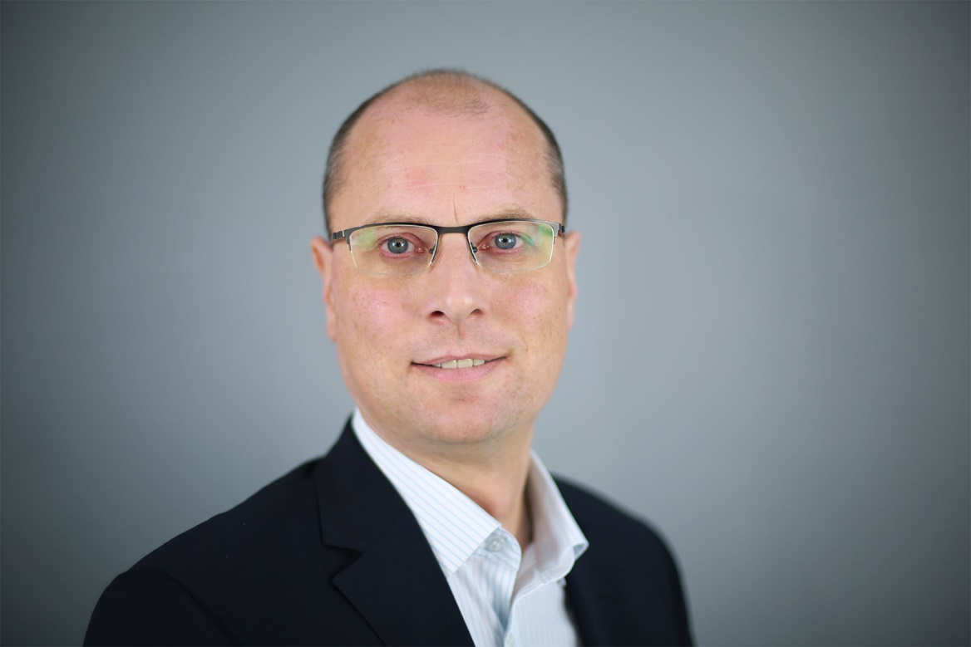
Caption: Robin Hees, CFO of Method Park Holding AG

