Press Release

Method Park opens new office
Hamburg complements the location network
As of January, Method Park services for software and systems engineering are now quickly and locally available for customers in Hamburg.
Erlangen, January 29, 2019 – As of January 1, 2019, a new location represents Method Park in Hamburg. With this location, the consulting company plans to establish greater customer proximity and to develop new industry solutions, including organizations in the maritime, logistics and aerospace industries in the Hamburg area. Method Park offers them its compiled know-how on the challenges in software and systems development, e.g. for the use of modern development methods, handling and improvement of development processes and compliance to industry norms and standards.
Greater Customer Proximity
“Efficient process management is a necessary condition for business success in numerous industries. With the new location in Hamburg, we can offer our expertise across more industries and – more particularly – locally”, says Volker Lehmann, Principal Consultant at Method Park and manager of the new location in Hamburg.
An Attractive Employer
The new Method Park representation in Hamburg is an attractive location for customers. “Additionally, we can now offer interesting positions within walking distance of the main train station and the harbor for new employees and applicants in the Hamburg area”, Sandra Grundl, Manager of Method Park Human Resources, describes the second motivation for the location which has recently been opened.
Location no. 6 in Germany
With Erlangen, Munich, Stuttgart, Hanover and Frankfurt on the Main, Hamburg is already the sixth German location of the permanently expanding Method Park Group. In addition to its German locations, Method Park is represented by three further locations in the US.
The address of the new location is:
Chilehaus A, Fischertwiete 2, 20095 Hamburg, Germany
Number of characters (space characters included): 1.830 characters
About Method Park
Method Park is specialist for innovative software and systems engineering in the safety-critical environments of the medical and automotive industries. Method Park’s portfolio includes consulting and engineering services, a comprehensive training program and the process management tool “Stages”.
Method Park was founded in 2001. On a worldwide basis, the company has coached its customers on process optimization, compliance to industry-specific standards and legal regulations. It has also consulted on the management of projects, products and quality assurance.
Method Park offers a practice-based training program on all current topics of software and systems engineering. Method Park offers training at its locations in Germany and other European countries, the US and Asia.
With “Stages”, Method Park offers an individually customizable process management tool which supports its users on the definition, communication and application of complex processes.
The company group has locations in Erlangen, Frankfurt on the Main, Hannover, Munich and Stuttgart as well as in Detroit, Miami and Pittsburgh in the US. With around 200 employees, Method Park generated an operative turnover of about 16 million euros in 2017.
For further information please contact:
Dr. Christina Ohde-Benna, PR-Assistant
Method Park Holding AG, Wetterkreuz 19a, 91058 Erlangen, Germany
Christina.Ohde-Benna@methodpark.de www.methodpark.com
Available pictures:
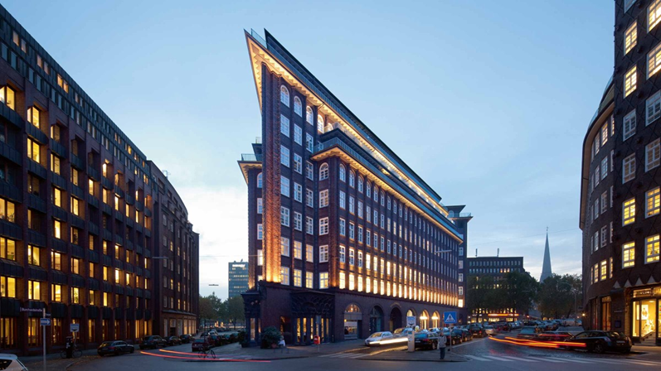
  - Method Park’s new office in Hamburg‘s „Chilehaus“

