Press Release

New Location Manager for Method Park Consulting GmbH
Marco Schuster switched to the consulting company based in Erlangen
On January 1, 2019, Marco Schuster took over the management of Method Park’s location in Erlangen. The quality and process expert will take on responsibility for promoting the important operations with Automotive SPICE®.
Erlangen, January 22, 2019 – Since January 1, Marco Schuster has been the new location manager of Method Park Consulting GmbH in Erlangen. After positions as Automotive SPICE® Principal Assessor and Instructor at Schaeffler or Managing Consultant and System & Software Development Quality Manager at Continental, he now takes on responsibility particularly for all operations around Automotive SPIC® at Method Park in Erlangen. Since 2001, automobile manufacturers in the US and Europe assess the development process performance of their suppliers based on this quality standard. In recent years, Automotive SPICE® has significantly gained importance in Asia as well.

Increase in Turnover with Automotive SPICE®
The business with consulting, coaching, training as well as the assessor training for the international automotive industry plays an important role for Method Park. Since mid-2010, the software & systems company based in Erlangen has recorded an increasing turnover in the sector of Automotive SPICE® consulting.

Expertise for the Automotive Industry
CEO Prof. Dr. Bernd Hindel is proud to announce that Method Park has succeeded in winning the support of Marco Schuster with years of experience in the automotive industry: “By recruiting Marco Schuster, we accommodate the increasing demand in consulting services in the automotive industry. His expertise as Automotive SPICE® Principal Assessor as well as Quality and Risk Manager excellently strengthens our portfolio and will provide new impulses in the team.”
Marco Schuster looks highly motivated forward to the new tasks: “I would like to further develop the consulting services for OEMs and suppliers. A holistic perspective on processes is particularly important for me. With that, we support our customers to not only further develop processes, but also master the challenges in product development.”
Number of characters (space characters included): 2.207 characters
About Method Park
Method Park is specialist for innovative software and systems engineering in the safety-critical environments of the medical and automotive industries. Method Park’s portfolio includes consulting and engineering services, a comprehensive training program and the process management tool “Stages”.
Method Park was founded in 2001. On a worldwide basis, the company has coached its customers on process optimization, compliance to industry-specific standards and legal regulations. It has also consulted on the management of projects, products and quality assurance.
Method Park offers a practice-based training program on all current topics of software and systems engineering. Method Park offers training at its locations in Germany and other European countries, the US and Asia.
With “Stages”, Method Park offers an individually customizable process management tool which supports its users on the definition, communication and application of complex processes.
The company group has locations in Erlangen, Frankfurt on the Main, Hamburg, Hannover, Munich and Stuttgart as well as in Detroit, Miami and Pittsburgh in the US. With around 200 employees, Method Park generated an operative turnover of about 16 million euros in 2017.
For further information please contact:
Dr. Christina Ohde-Benna, PR-Assistant
Method Park Holding AG, Wetterkreuz 19a, 91058 Erlangen, Germany
Christina.Ohde-Benna@methodpark.de www.methodpark.com
Available pictures:
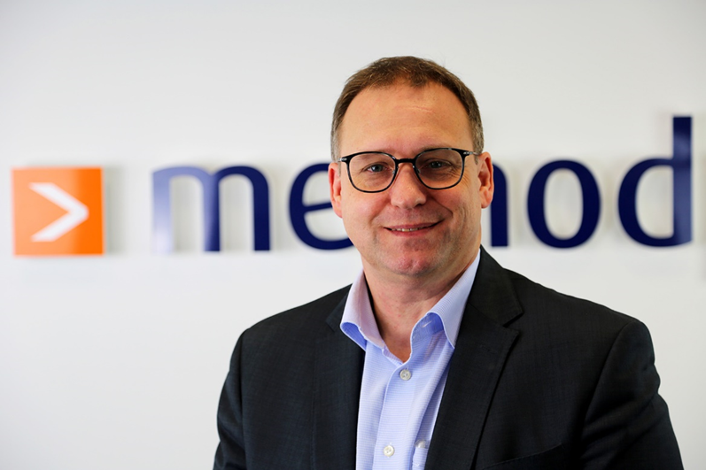
Marco Schuster: new location manager for Method Park Consulting GmbH

