Press Release

Sales Expert joins Method Park

The consulting company based in Erlangen strengthens its technical sales team for its process management tool “Stages” with the new team member Ingo Lachner and so intensifies its cooperation with IBM.

Erlangen, February, 7th, 2017 – The experienced sales manager and systems engineering expert, Ingo Lachner joins Method Park. With Ingo Lachner, the company consulting on software and systems engineering, based in Erlangen, is growing and strengthening not only its expertise, but also sales of its process management tool “Stages”.
Until the end of 2016, Ingo Lachner had been Sales and Techsales Manager at IBM for many years, responsible for selling and consulting on Rational/Watson IoT Continuous Engineering in Germany, Austria and Switzerland. At Method Park, he will grow the technical sales team for Stages in German-speaking countries.
Stages sales are increasing internationally. The latest new customers of Stages are global market leaders such as Ford, Fiat, Chrysler, Here, John Deere, Rockwell and Collins among others. These companies use Stages for defining, modelling and implementing their complex development processes and to prove compliance to standards.
Prof. Dr. Bernd Hindel, CEO of Method Park, says: “We are very proud to have gained the experienced sales manager and systems engineer Ingo Lachner and are able to intensify our cooperation with IBM.”
Number of characters (spaces included): 1.405
About Method Park
For many years Method Park has successfully offered consulting in questions of software for safety-critical systems in the automotive industry and in the medical technology area, for which the company develops its own software solutions. Method Park brings extensive know-how to fields with high and extremely high safety requirements. With this knowledge Method Park offers its customers a variety of solutions from a single source that contribute to the success of each company. Method Park is the competent partner for consulting, coaching, training, engineering services and products for all questions of software development processes. The "Stages" Web-based process management portal developed by Method Park supports users with the practical implementation of development processes. Stages ensures the realization of predefined quality standards and process models and can be integrated in all common development environments. Furthermore, Stages enables the global distribution of development tasks beyond corporate boundaries. Founded in Erlangen in 2001, Method Park employs around 150 persons at sites in Erlangen, Munich and Stuttgart, as well as in Detroit and Miami in the USA.
For further information please contact:
Dr. Christina Ohde-Benna, PR-Assistant
Method Park Holding AG, Wetterkreuz 19a, 91058 Erlangen, Germany
Christina.Ohde-Benna@methodpark.de www.methodpark.de
Available pictures:
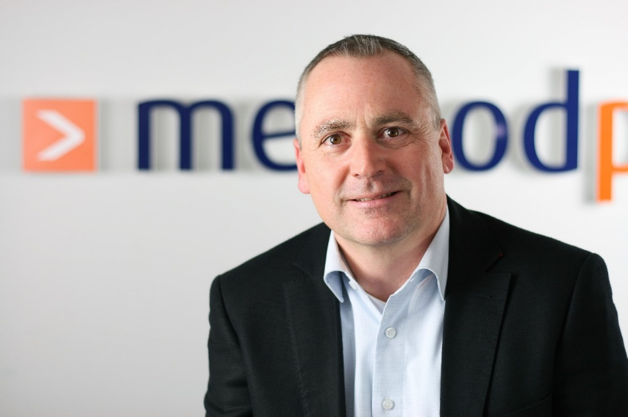
Ingo Lachner, Technical Sales Manager at Method Park

