Press Release / Upcoming Event

Erik Händeler – guest speaker at Method Park

Famous futurologist Erik Händeler will speak about the history of future at “Talk in the Park” events

Erlangen April 26, 2016 – Method Park was able to win the famous futurologist Erik Händeler for its “Talk in the Park” events. In July, Erik Händeler will speak about “The History of Future – Tomorrow’s Working World” at Method Park’s locations in Munich (July, 5), Stuttgart (July, 12) and Erlangen (July, 19).
In his presentation, Erik Händeler is considering success patterns determining productivity and prosperity of society. The current focus is on efficient use of knowledge. Individuals are not able anymore to maintain an overview of the quantity of information and are reliant on information forwarded by others. Dealing knowledge productively requires cooperation at eye level, transparency, willingness to compromise with others, ability to cooperate, long-term plans and authenticity instead of focusing on status.
For Method Park, the transfer of knowledge and know-how is particularly important, too. With its “Talk in the Park” events, Method Park has built a platform for cross-industry exchange of information and experience. During the events, participants have enough time for networking among each other. “Talk in the Park” was initiated as a non-profit event at Method Park’s location in Munich. Since then, the event has been successfully established in Stuttgart and Erlangen as well and welcomes many regular guests. Method Park considers itself as modern, innovative company seeking continuous exchange of information, knowledge and experience with its customers and market partners. Of course, future-oriented presentations – such as Erik Händeler’s – are part of this information exchange.
Please find further information about “Talk in the Park” on our website: https://www.methodpark.com/talk-in-the-park.html
Further information about Erik Händeler:
Erik Händeler was born in 1969. He worked for a daily newspaper during a traineeship and as municipal editor for Ingolstadt before he started studying economics and economic policies in Munich. Erik Händeler started working as independent economic journalist in 1997. He is a famous author, futurologist and specialist in the Kondratieff theory of long structure cycles. In 2010, he received the bronze medal for his economic science work by the Russian Academy of Sciences.
Number of characters (spaces included): 2399
About Method Park
For many years Method Park has successfully offered consulting in questions of software for safety-critical systems in the automotive industry and in the medical technology area, for which the company develops its own software solutions. Method Park brings extensive know-how to fields with high and extremely high safety requirements. With this knowledge Method Park offers its customers a variety of solutions from a single source that contribute to the success of each company. Method Park is the competent partner for consulting, coaching, training, engineering services and products for all questions of software development processes. The "Stages" Web-based process management portal developed by Method Park supports users with the practical implementation of development processes. Stages ensures the realization of predefined quality standards and process models and can be integrated in all common development environments. Furthermore, Stages enables the global distribution of development tasks beyond corporate boundaries. Founded in Erlangen in 2001, Method Park employs around 130 persons at sites in Erlangen, Munich and Stuttgart, as well as in Detroit and Miami in the USA.
For further information please contact:
Dr. Christina Ohde-Benna, PR-Assistant
Method Park Holding AG, Wetterkreuz 19a, 91058 Erlangen, Germany
Christina.Ohde-Benna@methodpark.de www.methodpark.de
Available pictures:
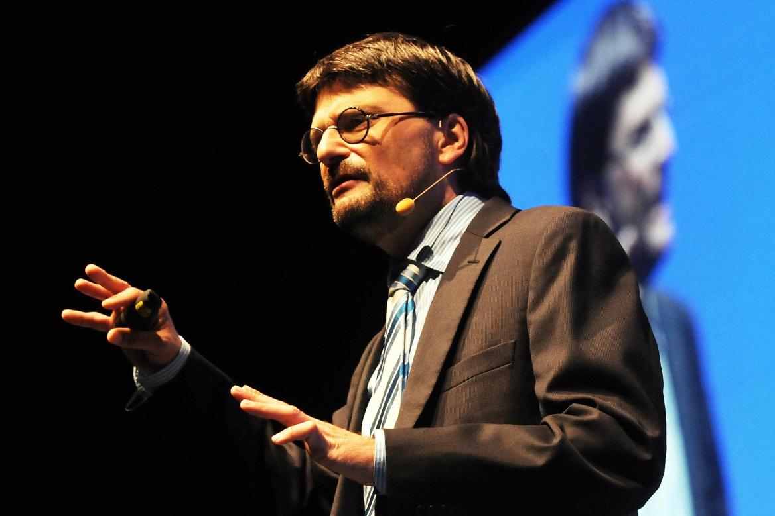
Erik Händeler

